
SCRATCH PROGRAMMING
LEVEL: GRADE 3-4
Test Type: Multiple Choice Questions
Total Questions: 30
Duration: 60 minutes
Date: ______________________
Instructions to Candidates:
Read all questions carefully before answering.
Each question has four options; choose the most appropriate answer.
Do not mark more than one option for any question.
Manage your time wisely — approximately 2 minutes per question.
Review your answers before submission.

- Which block is most commonly used to start a script so the program runs when the user clicks the green flag?

A) 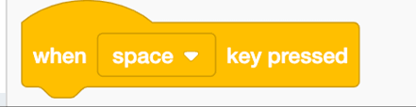
B) 
C) 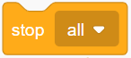
D) 

- How many times will the character say "Xpert" when this code runs? 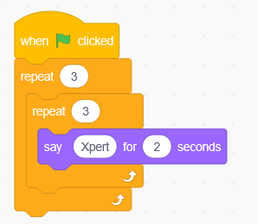
A) 3 B) 6 C) 8 D) 9

- You want your Sprite (character) to keep walking across the screen without ever stopping. Which "Control" block should you wrap around your "Move" block?

A) 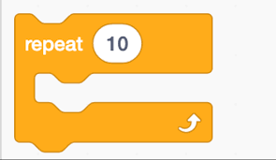
B) 
C) 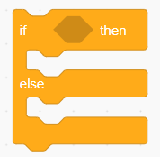
D) 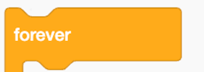

- You want your cat sprite to show a text bubble that says "Hello" for exactly 2 seconds and then disappear. Which block do you use?
A) 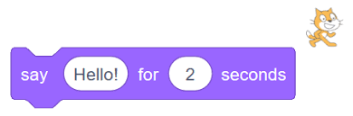
B) 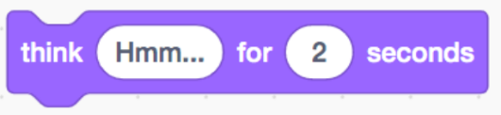
C) 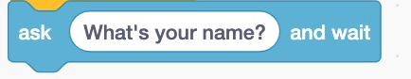
D) 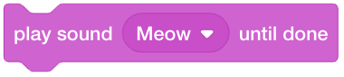

- Your sprite keeps walking off the right side of the screen and disappearing Which block makes the sprite automatically turn around when it hits the wall?
A) 
B) 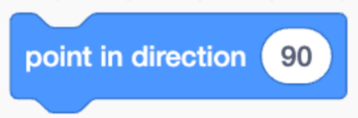
C) 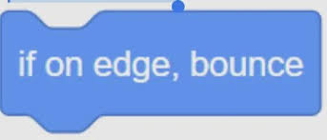
D) 

- Which block do you use to start your program when this sprite is clicked?
A)
B)
C) 
D) 

- Which block makes the cat say "Hello" for 2 seconds?
A) 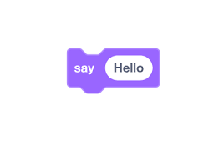
B) 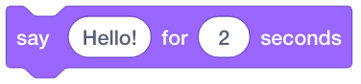
C) 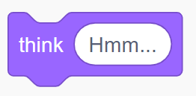
D) 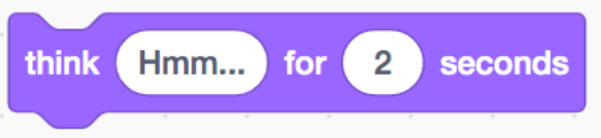

- Which block makes the sprite move 10 steps?
A) 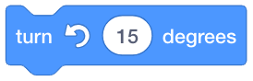
B) 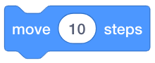
C) 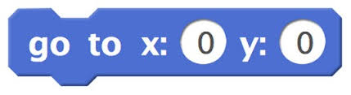
D) 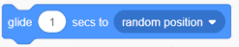

- How do you make your sprite look like it's walking?
A) Use the "next costume" block.
B) Change the color.
C) Make it bigger.
D) Use the "hide" block.

- Which block makes a sound?
A)
B)
C) 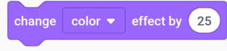
D) 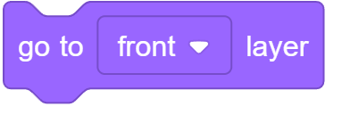

- What will happen if you use this code?
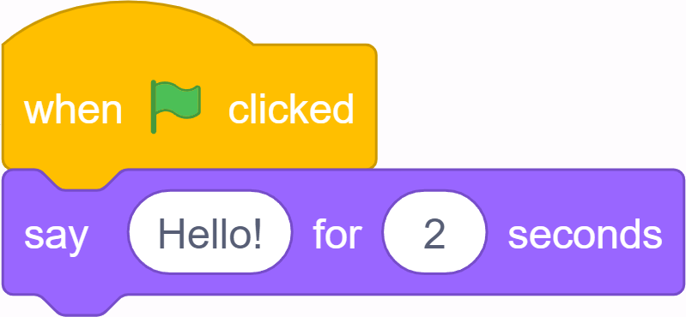
A) The sprite says nothing.
B) The sprite says "Hello" as soon as you click the green flag.
C) The sprite moves.
D) The sprite changes color.

- What does the  block do?
A) Makes the sprite faster.
B) Pauses the program for some seconds.
C) Makes a sound.
D) Changes the background.

- You want the sprite to move when you press the space key. Which block should you use to start the script?
A)
B)
C)
D) 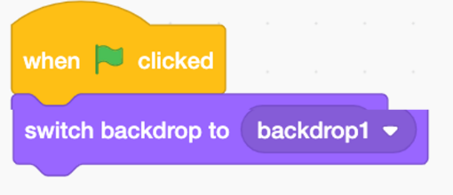

- How can you make a sprite go back to the center of the stage?
A)
B)
C) 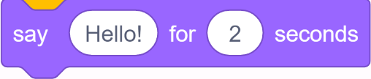
D) 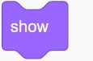

- What does the 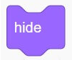block do?
A) Makes the sprite bigger.
B) Makes the sprite disappear.
C) Makes the sprite spin.
D) Makes the sprite talk.

- You want your sprite to move 10 times. Which block helps you do that without writing the same code again and again?
A)
B)
C)
D)

- Which block makes something happen again and again forever?
A)
B)
C)
D)
- If you put a "move 10 steps" block inside a "repeat 4" block, how many steps will the sprite move in total?
A) 10 steps
B) 4 steps
C) 40 steps
D) 14 steps

- How do you change the background of the stage?
A) Go to the "Backdrops" tab and choose a new one.
B) Use the "say" block.
C) Use the "move" block.
D) Use the "hide" block.

- How can you make your sprite look bigger?
A) Use the "change size by 10" block.
B) Use the "next costume" block.
C) Use the "go to x:0 y:0" block.
D) Use the "play sound" block.
- Which block makes your sprite think "Hmm..."?
A)
B)
C)
D)

- What does the block do?
A) It makes something happen always.
B) It makes something happen only when a condition is true.
C) It makes the sprite disappear.
D) It repeats something 10 times.

- You want the cat to say "Ouch" only if it touches the edge. Which sensing block can you use inside the "if" block?
A) [Touching mouse-pointer?]
B) [Touching color ?]
C) [Touching edge?]
D) [Key space pressed?]

- Where is the center of the Scratch stage?
A) x: 240, y: 180
B) x: 0, y: 0
C) x: -240, y: -180
D) x: 100, y: 100

- Which block makes the sprite point upwards (toward the top of the stage)?
A) [Point in direction 90]
B) [Point in direction 0]
C) [Point in direction -90]
D) [Point in direction 180]

- What does "change y by 10" do?
A) Moves the sprite right.
B) Moves the sprite left.
C) Moves the sprite up.
D) Moves the sprite down.

- What is a variable used for?
A) To change the costume.
B) To store information that can change (like a score).
C) To make a sound.
D) To hide the sprite.

- You want to make a score that starts at 0. Which block should you use?
A) [Change score by 1]
B) [Set score to 0]
C) [Show variable score]
D) [Hide variable score]

- How do you make the score increase by 1 when something happens?
A) Use "set score to 1".
B) Use "change score by 1".
C) Use "say score".
D) Use "hide score".

- If you want to draw with your sprite, which block category should you use?
A) Motion
B) Sound
C) Pen
D) Looks

ANSWERS
- B
- D
- D
- A
- B
- B
- B
- B
- A
- A
- B
- B
- B
- A
- B
- A
- B
- C
- A
- A
- B
- B
- C
- B
- B
- C
- B
- B
- B
- C

